Coordination of Entrepreneurs (2021)
WP3/ Development/3.2. «Entrepreneurs Centres»

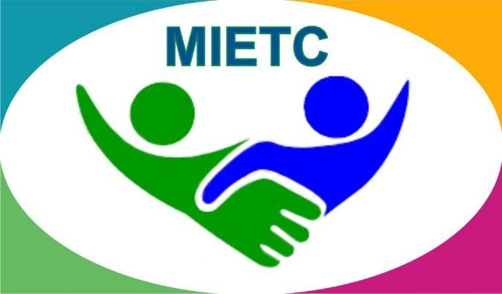
DEVELOPMENT OF A MASTER PROGRAMME IN THE MANAGEMENT OF INDUSTRIAL ENTREPRENEURSHIP FOR TRANSITION COUNTRIES
610198-EPP-1-2019-1-ES-EPPKA2-CBHE-JP

The information and views set out in this publication are those of the authors and do not necessarily reflect the official opinion of the European Union. Neither the European Union institutions and bodies nor any person acting on their behalf may be held responsible for the use which may be made of the information contained therein.

Detailed information is available in the Handbook

https://www.keu.kz/en/section-table/31-materialy/10080-handbook-of-the-entrepreneurs-center.html

Job Fair: we invite financiers!
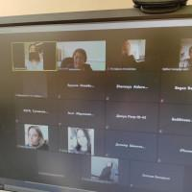
The financial sector in the country is represented by various institutions, including banks. Our university trains highly qualified specialists for the banking sector, who successfully work in the banks of the city and region.
As part of the Job Fair, on March 15, 2021, an online meeting was held at the ZOOM site with representatives of the banking sector of the city of Karaganda: consumer lending departments of DB Alfa Bank JSC, VTB Bank Kazakhstan JSC, Eurasian Bank JSC, Zhilstroysberbank of Kazakhstan JSC, Bank Center Credit JSC.
Despite the seemingly identical policy, each of the banks has its own peculiarity in the selection of personnel, their training and personnel development of specialists.
Dear graduates, if you plan to link your professional activities in the banking sector, please contact office 107, where you will receive additional advice on each of the banks.

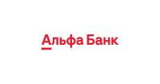

Job Fair: banks are waiting for our graduates!
In continuation of the meetings with financial structures, a meeting was organized for graduate students in baknkami.
On April 01 and 02, 2021, online meetings were organized on the ZOOM platform with representatives of Nurbank JSC, DB Bank Home Credit JSC, ATF Bank JSC, RBK Bank JSC, Halyk Bank JSC, as well as subsidiary bank (DB) Sberbank JSC.
Students were told about vacant positions, requirements for young professionals depending on their future activities in the bank.
Go to Room 107 and find out more.
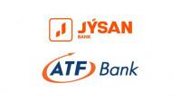

Meeting with representatives of «Nurbank» JSC and SB «Sberbank» JSC
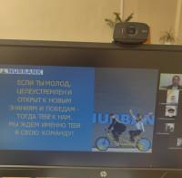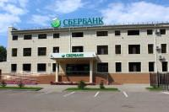
On April 01 and 02, 2021 year, the Resource Center of the Strategic Development Department organized online meetings on the ZOOM platform with representatives of «Nurbank» JSC, as well as a subsidiary bank (SB) of «Sberbank» JSC with graduate students.
Representatives of «Nurbank» JSC, as well as SB «Sberbank» JSC together with the Director of the Resource Center Kose Zh.K. conducted an informational and explanatory conversation about the passage of the stages of employment of young specialists in these financial institutions. Bank representatives informed about the available vacancies, about the requirements, as well as about the opportunities for professional growth; expressed their wishes for further cooperation with our university.

Meeting with representatives of «ArcelorMittal Temirtau» JSC
On April 06, 2021 year, students of the specialties "Computer Science and Software" and "Information Systems" met with the Director of the Main ITC of JSC «ArcelorMittal Temirtau» S.N. Rogov.
The «ArcelorMittal» Group is the world's leading mining and metals corporation with offices in 60 countries and production facilities in 18 of them.
«ArcelorMittal» Corporation is a leader in all major steel markets, including products for the automotive and construction industries, household appliances and packaging. The company's products are presented on markets in 160 countries around the world. This company allows you to build your career ladder not only in our country, but also gives you the opportunity to work in other countries.
At the moment, the company invites graduates of our university to the following positions: business analysts, programmers, system administrators, network administrators, etc. Areas of work of these specialists: financial management, management accounting, project management, sales, material flows, system administration, etc.
Representative of the company JSC «ArcelorMittal Temirtau» Rogovoy S.N. expressed wishes for further cooperation with our university.
If you have any questions about preparing for a resume, preparing for an interview with this or other companies, please contact the Resource Center (room 107). Phone: +7 (7212) 44 15 68.

Job Fair: at the forefront of public interests.
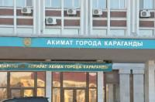
Is it easy to be a civil servant? How is it to preserve the interests of the state and help its citizens? Is it possible to go into big politics?
On April 13, 2021, the Resource Center of the Karaganda University of Kazpotrebsoyuz organized a meeting of graduates with representatives of state structures: GU "Department of the Agency of the Republic of Kazakhstan for Civil Service Affairs in the Karaganda region", KSU Employment Center of the Akimat of the Abai district, GU Akim's Office of the city Shakhtinsk, GU Apparatus of the akim of the Karaganda region, GU Apparatus of the akim of the district named after him.Kazybek bi of Karaganda city, GU Apparatus of akim of Abai city, GU Apparatus of Akim of Osakarovsky district, GU Apparatus of akim of Agadyr Shetsky district, GU Apparatus of Akim of Karaganda city.
Representatives of akimats told students about the specifics of working in state institutions, working with the population, implementing state programs and many other things.
If you still have questions, come to room 107, and we will tell you how to get a job in government agencies.

Meeting with representatives of the State Institution «Department of the Agency of the Republic of Kazakhstan for Civil Service Affairs in the Karaganda region»
On April 13, 2021 year, the Resource Center of the «Karaganda university of Kazpotrebsoyuz» organized a meeting of graduates with the State Institution «Department of the Agency of the Republic of Kazakhstan for Civil Service Affairs in the Karaganda region».
The Agency is a law enforcement body that is responsible for the formation and implementation of the anti-corruption policy of the Republic of Kazakhstan and coordination in the field of combating corruption, as well as the identification, suppression, disclosure and investigation of corruption offenses.
The representative of the state institution Oral Indira explained about the procedure for admission to the administrative and law enforcement service. The invitation of the graduates of the «Karaganda university of Kazpotrebsoyuz» to pass testing for admission to the civil service was also announced.
If you have any questions about writing a resume, preparing for an interview with this or other companies, please contact the Resource Center (room 107). Phone +7 (7212) 44 15 68.

The job fair is in full swing!
Production, services, sales, construction, consulting, high technology.... Where do you see yourself after graduation?
Our already traditional Job Fair will help you choose the field and place of further activity, taking into account your abilities and interests.
On April 14, 2021, the Resource Center organized an online meeting within the framework of the Job Fair with the KSU "Employment Center of the Akimat of the city of Karaganda". The meeting was attended by companies participating in the state program "Youth Practice" and "With a diploma to the village": Rem Stroy Portal LLP, Vershina K2 LLP, Fair Light of the Milky Way LLP, Mikomp LLP, Leader AT LLP, Kraftmetiz LLP, Intur LLP.
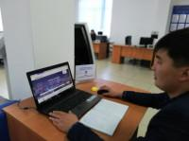

Youth practice: conditions, opportunities, experience.
On April 14, 2021 year, the Resource Center organized an online meeting within the framework of the Job Fair with the director of the KSU "Employment Center of the Akimat of Karaganda City". Students and undergraduates of graduate courses were invited to the meeting, the purpose of which was to inform about the implementation of the "Youth Practice" program.
Youth practice is organized for graduates of educational organizations in order to obtain initial work experience in the profession (specialty) received. Unemployed people under the age of 29 are sent to youth practice for 3 years after completing their studies. The duration of the youth practice is up to 6 months. The amount of the subsidy per month is 25 MCI. Labor is paid monthly.
The representative of the state institution Nurzhan Khamitovich Syzdykov answered all questions regarding the stages in state support for further employment after the end of the internship. This information is especially relevant for students completing their studies on a state educational order.
For all questions, graduates can contact the Employment Center by phone +7 775 644 3580, +7 7212 996394, as well as the Resource Center of the University (room 107, phone +7 7212 441568).
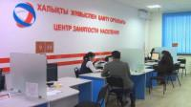

Alumni meeting with subsidiary “VTB Bank JSC (Kazakhstan)”
On May 04, 2021 year, an online meeting of university graduates took place on the ZOOM platform with the director of the branch of the city of Karaganda of Subsidiary JSC "VTB Bank (Kazakhstan)" Temirkalin K.T.
During the meeting with future specialists, the head of the bank clearly explained all the working conditions in a financial company, and it was also announced that at the moment there are 2 (two) open vacancies "credit manager of small business".
Students inquired about career opportunities and job responsibilities.
If you have any questions about writing a resume, preparing for an interview with this or other companies, please contact the Resource Center (room 107). Phone +7 (7212) 44 15 68.

Meeting with representatives of LLP "Amanat"
On May 18, 2021 year, the Resource Center of the Department of Strategic Development organized a meeting at the ZOOM platform with representatives of Amanat LLP with graduate students and undergraduates.
The main activity of the pharmaceutical company "Amanat" LLP is the wholesale of medicines, medical products, etc.
At the moment, the company invites graduates of our university to the following positions in the departments: DB and IS administration. And also the representative of Alibayeva N.A. informed the students about the opportunities for learning, growth and development.
Such meetings are an excellent opportunity for graduate and undergraduate students to meet and communicate with employers, get advice on employment issues.
More detailed information about the company and employment in it can be obtained from the Resource Center (107 room) Phone +7 (7212) 44 15 68.

Meeting with representatives of LLP «Delta M Group»
On May 26, 2021 year, the Resource Center of the Department of Strategic Development organized a meeting at the ZOOM platform with representatives of «Delta M Group» LLP with graduate students.
The international group of companies «Delta M» has been successfully doing business in Ukraine, Kazakhstan, Russia, Kyrgyzstan, Poland, Moldova and Belarus for more than ten years, combining Western standards with a deep understanding of the market. In 2015, the official opening of an office in Kazakhstan, Karaganda, took place.
At the moment, the company invites graduates of our university to the following positions: managers for debt collection and managers for the sale of banking products and services. Students were provided with information about learning, growth and development opportunities.
More detailed information about the company and employment in it can be obtained from the Resource Center (107 room) Phone +7 (7212) 44 15 68.

Meeting of JSC "Financial Center" with students, undergraduates and doctoral students of graduate courses of students under the state educational order.
On April 28, 2021 year, the Resource Center held an online meeting with students, undergraduates and doctoral students of graduate courses of students under the state educational order. The topic of the meeting was changes in the regulatory documents for the distribution of young specialists.
Representatives of the JSC "Financial Center" Lyazzat Abisheva and Baden Inesh explained in detail all the moments and stages of distribution, reported on the terms and situations that are exempted from working off.
During the meeting, the alumni asked topical questions about the changes made to the processes of distribution and working off the grant.
For more information, contact the Resource Center (office 107) Phone +7 (7212) 44 15 68.

Opening of the "Job Fair 2021"
With the beginning of the academic year, we begin a cycle of company presentations within the framework of the annual "Job Fair".
The first company this year was the branch of JSC "Nurbank" in Karaganda. The meeting took place on September 20 this year at the ZOOM site.
The product line of Nurbank JSC currently fully meets the requirements of the market. This fact is especially important for young professionals, whom the bank expects to see among our graduates.
The meeting was attended by the Deputy Director for Retail Business of Nurbank JSC in Karaganda, Artykbayev Aydin Rashidovich and the head of the commodity lending department Linnik Valentina Petrovna, as well as graduate students of our university.
Dear students, if you have an interest in working at this bank, you want to do an internship or internship there, please contact the Resource Center (office 107).
Follow the news in the group in Contact ★ KEU┃Employment ★ I WANT TO WORK ★, on the Instagram page @resource_center_karuk.
Be sure to subscribe!

New meetings - new acquaintances - presentation of the Resource Center.
The University's Resource Center is constantly working with graduate students on preparing for employment, providing assistance in finding vacant positions, preparing and passing interviews, and compiling resumes. So this week meetings were held with graduate students.
The meeting was devoted to familiarization with the directions of the center's work, its capabilities.
The meeting was attended by graduate students of all educational programs of the university. This is the first meeting this year and there will be more meetings with partner companies ahead.
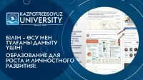

Efes Kazakhstan is waiting for our IT specialists!
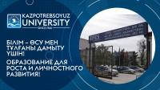
Today there was a meeting with our "old" partner – Ephesus Kazakhstan. The meeting was held within the framework of the Job Fair -2021.
A representative of the company, a talent specialist Farida, provided information about the possibilities of a paid internship at the plant in Karaganda. The internship is offered for graduates of IT specialties. This is a great opportunity to start your professional career right away in an international company (the head office is located in Turkey).
Dear IT graduates of 2022, if you are interested in understanding work in production, you want to earn a little extra money, you do not know where to do an internship and what object to write a thesis about, look at the Resource Center, where you will get additional information and from where you can send your resume for an internship.
Contact Zhanna Komekovna in office 107.

Master class on resume preparation and preparation for an interview
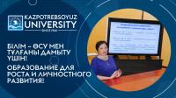
Candidate of Economic Sciences, business coach, Professional manager and Professional Certified Coach ICU Zhanna Komekovna Kose on 18.11.2021 held a master class on resume compilation and preparation for an interview for graduate students. The main objectives of the master class are to teach self-presentation skills, which are important when applying for a job, public speaking, negotiating, meeting new people.

Eurasian Foods JSC invites our graduates to work
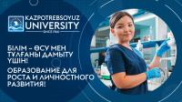
Karaganda University of Kazpotrebsoz closely cooperates with large industrial companies in the region. On December 2, 2021 representatives of Eurasian Foods JSC, a part of the Eurasian Foods Corporation holding, met at the university. Eurasian Foods Corporation Holding is one of the leading and significant enterprises of the food industry of Kazakhstan and Central Asian countries, the recognized leader of the republic among producers of fat and oil products that meet the highest international standards, with a production volume of more than 150,000 tons per year. The holding consists of three largest enterprises of the food industry of the Republic of Kazakhstan: JSC "Eurasian Foods Corporation", Almaty, JSC "Eurasian Foods", Karaganda and LLP "Eurasian Milk", Petropavlovsk. The main principles of the Eurasian Foods Corporation holding are the continuous improvement of product quality, focused on consumer preferences, and ensuring the safety of its production.
At the enterprises of the holding, constant quality and safety control is carried out at all stages of production: from receiving input raw materials to the release of finished products. For this purpose, the plants have created and successfully operate their own certified physico-chemical and microbiological laboratories, which are equipped with the most modern equipment, a food safety management system has been introduced. Employees for these laboratories were selected by representatives of the Karaganda plant among the final year students of the educational program "Technology of food products" of the Karaganda University of Kazpotrebsoyuz.
Oksana Funt of the innovative technological laboratory of Eurasian Foods JSC - Margarine Plant, told about the main activities of the company, voiced the requirements for the company's employees and her laboratory, outlined the necessary skills and competencies, answered students' questions about social guarantees of employees, the recruitment procedure. A preliminary competitive selection of applicants was conducted among interested parties.
We are looking forward to the results and hope that our guys will be able to become new worthy representatives of this company in the future!
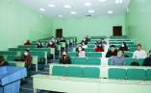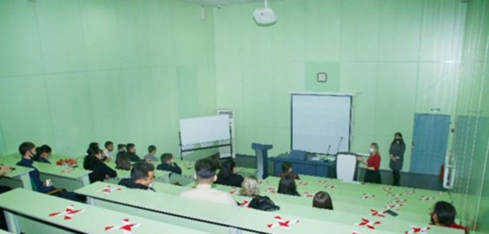

Pharmaceutical company "Amanat" LLP
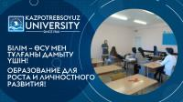
Karaganda University of Kazpotrebsoz closely cooperates with large companies in the region. On December 22 and 24, 2021, a meeting with the head of the Personnel Department of Pharm LLP took place at the university the company "Amanat".
The representative of the company spoke about the main activities of the company, voiced the requirements for the company's employees, outlined the necessary skills and competencies, answered students' questions about social guarantees of employees, the recruitment procedure. A preliminary selection of applicants was conducted among interested parties.
We are looking forward to the results and hope that our guys will be able to become new worthy representatives of this company in the future!

